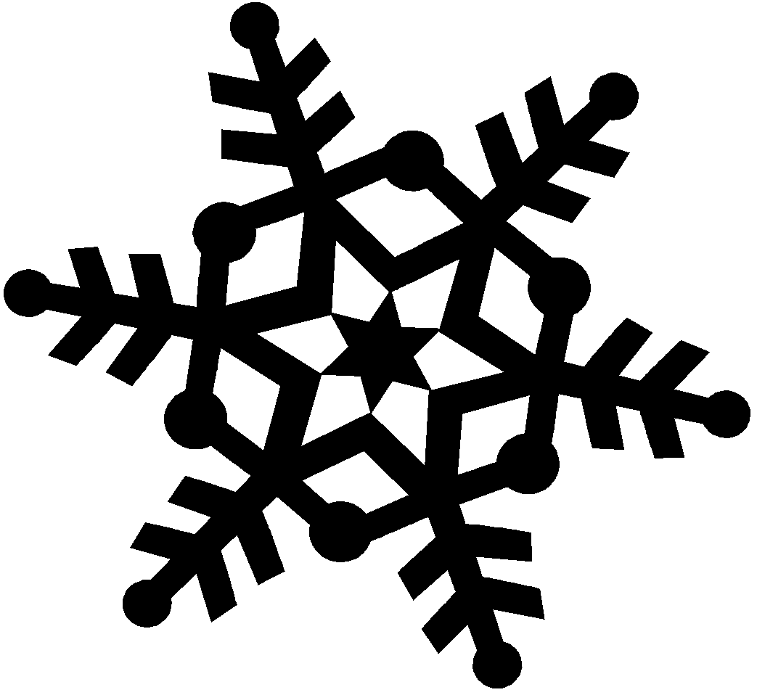
Winter Snow – Creative Ways to Teach STEM
VIRTUAL EECO Winter CONFERENCE January 28th and 29th, 2022

Schedule and Session Descriptions
Friday- January 28th, 2022 Zoom Link:
6:30 – 7:00pm Welcome and EECO Update Current events and programs going on with EECO and partnering organizations.

7:00pm Let’s Have Fun with Index Cards!
We know. You can barely contain your index card enthusiasm, right? Join Carrie Elvey from The Wilderness Center for an hour of games, activities, and random nerd absurdity - using just index cards. We’ll provide the index cards, you provide the drinks, Carrie will provide the absurdity. Join us at 7pm via zoom.

Saturday – January 29th, 2022
9am Welcome
9:05-10:05am Session I
10:15am-11:15am Session II
11:15 Return to main zoom
11:15-12:00 Lunch Break
12:00-1pm Return to main room, Keynote
1-2pm Session III
2:10-3:10pm Session IV
3:10-3:20 Final Questions, Feedback and Evaluations

Keynote Speaker:
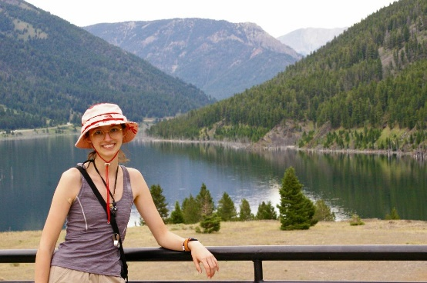
“Ruthy” Mackenzie Rutherford, a researcher/student at Miami University
Ruthy will discuss her research, the climate and the need for diversity in the GEO sciences.
Ruthy (Mackenzie) Rutherford
Miami University Class of 2022 | College of Arts and Sciences
Geology Major
Creative Writing Minor | Global Perspective on Sustainability Minor
GEODES | President
Sigma Tau Delta | President
Miami University Geological Society | Vice President
Sustainability Council | Representative
DAC Council | Representative
Onyx Council | Representative

Session I Presentations:

Discovering Soil is Alive: Linda Pettit and Amy Tressler
In this presentation participants will discover that soil is alive as we uncover invertebrates living below. We will determine that soil is complete a habitat, meeting the needs of the animals that live there. We will discuss the adaptations that some of these soil superheroes have to live underground and how some of them even make our soil healthy.

Common Ohio Pollinators & the Plants they Love: Jenny Adkins
If you're looking for a glimpse into summer, with colorful photos of flowers and insects, this presentation is for you! Jenny Adkins, Lead Botanist and Professional Wetland Scientist from MAD Scientist Associates, will lead a talk on the who's, what's, when's, and where's of common Ohio pollinators. She'll also address ways to manage your property for the benefit of these creatures and opportunities for data tracking through citizen science programs and classroom study.

Session II Presentations:

Finding Frosty: Jennifer Ellsworth
Critical and creative thinking exercises for nature in winter.
Warm up this winter with nature challenges that encourage creativity, problem solving and collaboration. Come prepared to test your skills with a tabletop escape room and landscape scene investigation.
Upper Elementary/Middle School

Appalachian Stewards Unit: teaching about food webs and symbiosis with American Ginseng.: Joe Brehm, Rural Action
Rural Action's Sustainable Forestry and Environmental Education programs joined forces to create a unit featuring American Ginseng. We call it the Appalachian Stewards Unit, and serves as our counter-narrative to trash tv shows like Appalachian Outlaws that popularize poaching of ginseng. American Ginseng is one of the most famous and valuable plants in eastern North America. Our team will take participants through a slide show and hands-on activities that use ginseng as a powerful teaching tool. This curriculum is primarily for 4th-6th grade but can be adapted for older age groups, including adults.

Session III Presentations:

The Environmental Heroes: Field Science Program in an Urban Watershed: Kathryn Kwiatkowski and Students, Case Western Reserve University
Middle and high school students share their authentic field research monitoring habitats and reptiles in the Doan Brook Watershed in University Circle. This after school environmental educational experience prepares students for potential environmental related careers and for being informed citizens. The audience will be engaged in simulated field data collection and monitoring techniques employed in the research. Students will share how this work supports their classroom experiences, prepares them for college, provides opportunities to meet environmental experts, and builds the framework for stewardship and conservation of our natural world. They will share their advocacy efforts around critical environmental issues with a strong focus on encouraging the Ohio legislature to develop a Climate Action Plan (33 other states have a CAP).

Session IV Presentations:

Developing Career Skills using the Believe in Ohio framework: Sheila Cubick
Join me on the metaphorical journey through the Believe in Ohio Roadmap to Future Jobs and Prosperity! Explore some of our curriculum resources and activities during this hands-on session that will introduce you to this exciting free STEM and Entrepreneurship program for Middle and High School students. Learn about the process from Idea Generation to Proof of Concept to completed STEM Commercialization Plan. The program is available to schools and organizations for in-school or after-school programs. Program incentives for teachers and students encourage program participation which builds life-long career skills for ALL participants!!

Spotting the Spotted Lanternfly: Denise Brooks
Spotted lanternfly is a recently-discovered invasive insect in Ohio that will wreak havoc on our trees if left unchecked. Learn how to prepare for the invasion to land labs, woodlands and outdoor spaces by starting an early detection network of citizen scientists using 21st century skills and various apps.

