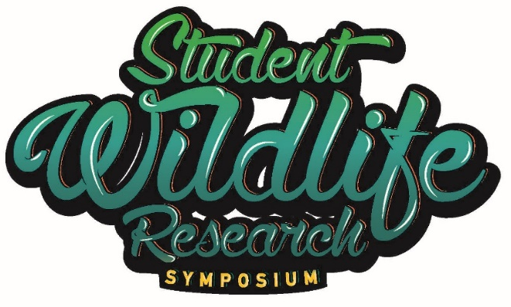

2022 Annual EECO Conference
March 31, 2022

9:00-9:45am Registration and Poster Set-up
10:00am Opening Remarks- Jen Dennison, ODNR-Division of Wildlife
10:15 am Keynote Speaker: Gabriel Karns, Ohio State University-Building Student-Centered Research Partnerships
10:45 am Speaker: Kip Brady, highlights of New Philadelphia School’s program and some of their research
11:15 pm Speaker: Jim Reding, highlights of Granville Local School’s program and partnering with USFWS
11:45 am Speaker: Jen Dennison, Division of Wildlife, AFWA’s Conservation Toolkit resources and more
12:00 pm Lunch
12:30 pm Poster Session: Students will present their research posters. Please see abstract for details.
1:15 pm Tracy Cindric: Professional development for teachers on citizen science program for schools—3hrs.
4:30 pm Adjourn
Thank you to the following Student Wildlife Research Symposium sponsors:
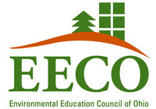
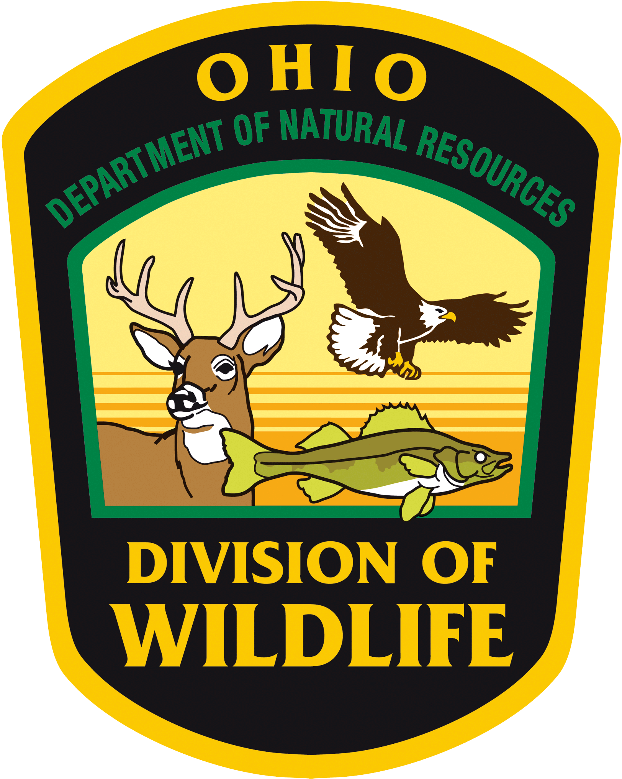

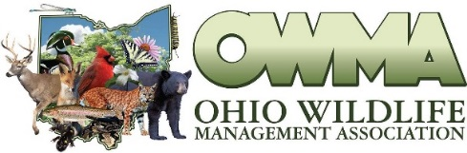
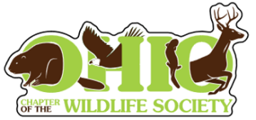
Thank you to the OCTWS and the OWMA for their support of our student presenters and their teachers

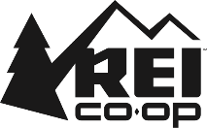

Thank you to REI for donating water bottles for each presenter and teacher!

Speaker Biographies
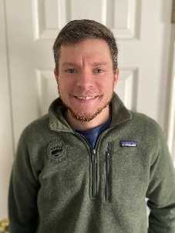
Keynote Speaker-Gabriel Karns, The Ohio State University: Gabriel Karns shares a co-appointment as a member of the Terrestrial Wildlife Ecology Lab (TWEL) in the School of Environment and Natural Resources at Ohio State University and senior lecturer and Ecolab manager at The Ohio State University-Mansfield. He earned wildlife science degrees from North Carolina State (BS and MS) and Auburn University (PhD) before becoming a part of the TWEL Lab almost a decade ago. He teaches a number of senior-level classes including Wildlife Ecology Methods, Wildlife Habitat Management, and the Capstone course for Wildlife and Forestry majors, as well as 1st-year curriculum in environmental communication and natural resources data analysis. His research focus has been aimed across several primary focal areas: identifying wildlife habitat conservation challenges and win-win’s via vegetation management on utility corridors and rights-of-ways, human dimensions of consumptive outdoor recreation, and maple production for non-timber forest products in Ohio, to name a few.

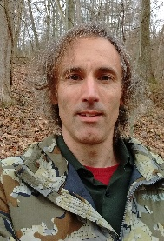
Kip Brady-New Philadelphia School District: Over the past 22 years, Kip Brady has taught a variety of science courses at New Philadelphia High School that focus on ecology and environmental science. His educational philosophy is strongly rooted in the belief that experience is the best teacher, and his career has been defined by efforts to engage students in deep, authentic experiences with their local landscape. These experiences generally take the form of field studies designed to answer original research questions about relationships between human land use, biodiversity, and ecosystem function.

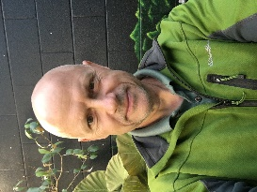
Jim Reding-Granville School District: Jim Reding graduated from The Ohio State University with a degree in Natural Resource Management and Secondary Life Science Education. He has been a teacher for 32 years and is currently teaching AP Environmental Science, Ecology and a class on Sustainable Agriculture for the Granville Exempted Village School District. Along with teaching, he manages the school’s organic garden, greenhouse and 100 acre “Land Lab” created by his students. His passion for teaching is founded in his belief that his students are our future and that when empowered, they can do amazing things. He lives in Granville, Ohio with his wife and four kids. His hobbies are all outdoors.

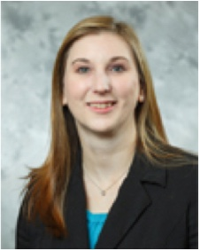
Tracy Cindric-BSCS Science Learning: After earning a B.A. from Capital University and an M.A. in teaching biology from Miami University, Tracy Cindric taught middle and high school science classes. She also taught preservice science educators at Ohio Wesleyan University and Capital University. Tracy created and facilitated professional development workshops on science content and technology integration, collaborated as an instructional coach to support teachers, and served on the Board of Directors for both the Science Education Council of Ohio (SECO) and Environment Education Council of Ohio (EECO). She was a science consultant at the Ohio Department of Education (ODE) and the Ohio Resource Center (ORC). While at ORC she led the development of CURIOUS KIDSS. Most recently Tracy served as a technology integration specialist for ODE.

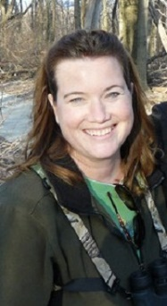
Jen Dennison-Ohio Division of Wildlife: Jen Dennison is the Wildlife Education Coordinator for the ODNR-Division of Wildlife (DOW). Jen has been with the DOW for 26 years, and in her current position for 22 years. She has a BS in Environmental Education, Communications and Interpretation with a Specialization in Wildlife Management from The Ohio State University. She is the state Project WILD Coordinator, ODNR Advisor to the Environmental Education Council of Ohio’s Executive Board, the ODNR Representative to the Ohio EPA’s OEEF Board, and a Network Regional Leader for Science for Ohio Department of Education. She has worked in the EE field for over 28 years in various education and leadership positions.

