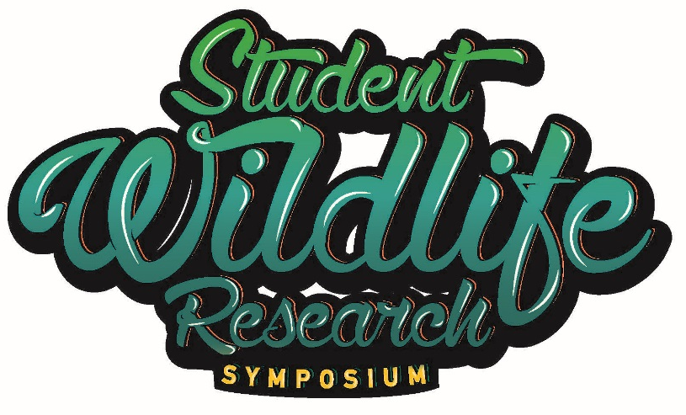

52nd EECO Conference
April 4, 2019

9:00-9:45am Registration and Poster Set-up
10:00am Opening Remarks- ODNR-Division of Wildlife-Scott Butterworth, Moderator
10:15am Keynote-Jim Reding-Granville High School—Impacts of Student-led Research on Conservation in the Future
11:00am Cate Banks, Granville High School—Maple Sap (Syrup) Production in a Changing Climate--Using historic and current data, we will look at the impact of several climate factors (temperature, precipitation, photo-period) on the production (volume) and quality (sugar content) of maple sap.
11:25am Bryan Rego and Thomas Butler, University School-- The occurrence and impact of microplastics in freshwater ecosystems—Microplastics pollution is of increasing concern in both freshwater and marine ecosystems; however, less is known about the presence and impact of microplastics in freshwater ecosystems. This study aims to document microplastic pollution in a river ecosystem and whether or not freshwater mussels uptake microplastics from their environment.

11:50am Introduce Poster Presenters
12:00pm Lunch-- Meet a Biologist! Meet and greet with ODNR and other resource agency staff. Meet Wildlife Officers, Wildlife Area Managers, and Fish Management staff and see their equipment too. This is an opportunity to interact with professionals in the field of environmental science.
1:15pm Poster Session-Review Posters and discussions with students—See Poster Session abstract for descriptions.
2:00pm Tristano, Tristano, Hines, & Sharp, New Philadelphia High School — Bird and mammal diversity in reforested abandoned and reclaimed surface coal mines. -- We compared the bird and mammal diversity of forested abandoned and reclaimed surface coal mines using game cameras and elevated feeding platforms. Bird and mammal species richness were significantly greater in forested abandoned mine land. Our results suggest that modern reclamation practices yield landscapes with unique and simplified vertebrate communities.
2:25pm Emma Reamer, Granville High School—Wetlands in the Agricultural Landscape-- This presentation will look at wetlands in the Granville Schools Land Lab and the potential role they play in mitigating the impact of the surrounding agricultural land. We will focus on the ecosystem services derived from the wetland and the possible impact the runoff is having on the biodiversity of the wetland.
2:50pm Dylan Berr, University School—Managing Predator and Prey Relationships in Lake Kilroy--Lake Kilroy is a small inland lake stocked with bluegill, largemouth bass, and pumpkin seed. It also supports a small brook trout population, maintained by an active trout hatchery. Current management objectives are to reduce the competition between bass and brook trout to help increase brook trout success.
3:15 pm OCWS/OWMA Presentation (tentative) and Closing Remarks-Jen Dennison, Wildlife Education Coordinator, ODNR-Division of Wildlife
3:30 pm Safe Travels! See you next year!

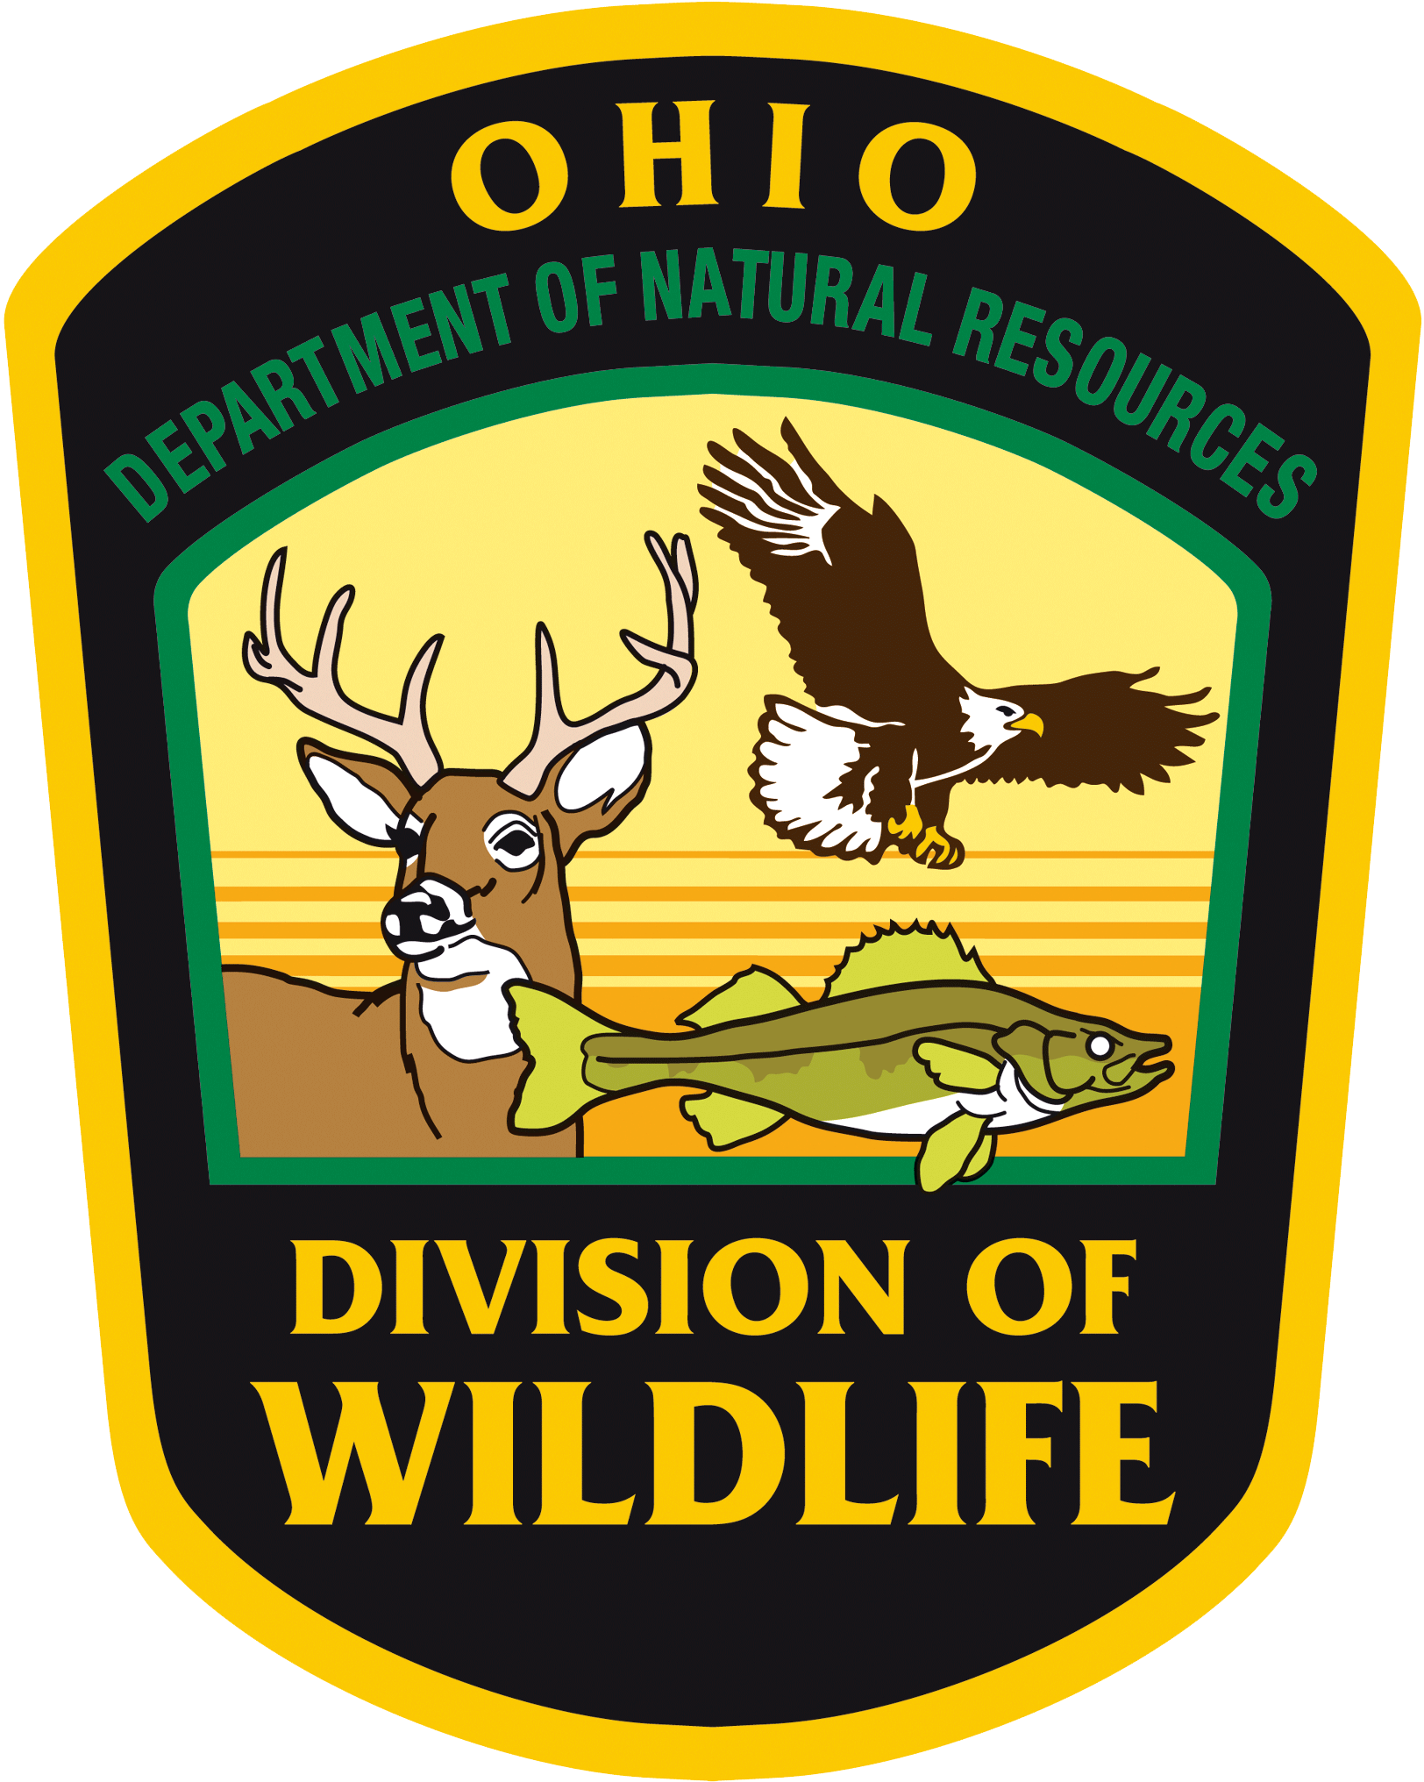
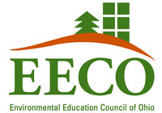
Thank you to the following Student Wildlife Research Symposium sponsors:

Thank you to the OCTWS and the OWMA for their support of our student presenters and their teachers.
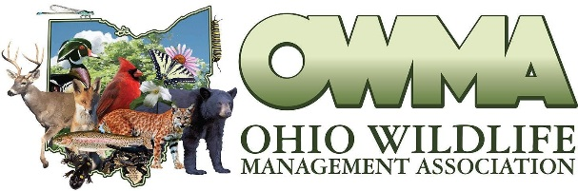
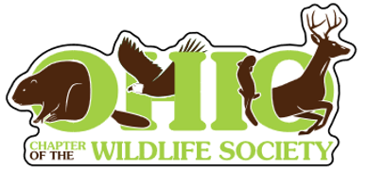

The Ohio Chapter of The Wildlife Society and the Ohio Wildlife Management Association is thrilled to partner with our state's up-and-coming conservationists through the Student Wildlife Research Symposium. In strong support of all students participating, we will be awarding everyone a signed copy of Aldo Leopold's Sand County Almanac, a newly-released decal sticker from the Ohio Chapter of The Wildlife Society, an invitation to highlight their project in our bi-annual newsletter that is distributed to many of Ohio's wildlife and natural resource professionals, and an invitation and discounted registration to the 2020 Ohio Wildlife Management Association Conference.

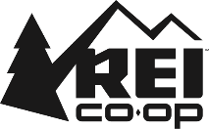
Thank you to REI for donating water bottles for each presenter and teacher!

